Assorted Sandwiches

The Falls Victoria Sponge

Macarons

Stem Ginger Flapjack

Tiffin

Plain Scones

Helen Slice

Fudge Krispie

Lemon Posset

Afternoon Tea £12.95

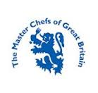

The Falls of Feugh Restaurant
Bridge of Feugh
Banchory, AB31 6NL
01330 824171
enquiries@thefallsoffeugh.com
www.thefallsoffeugh.com
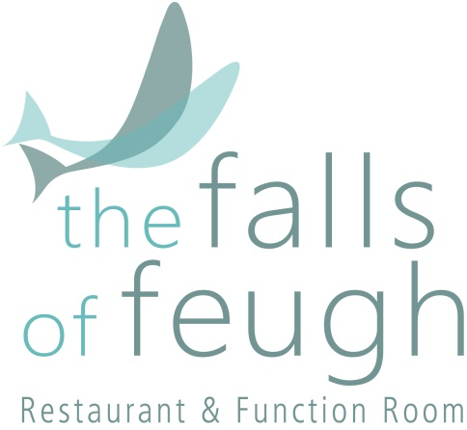

Take Away
Afternoon Tea

“There are few hours in life more agreeable than the hour dedicated to the ceremony known as
Afternoon Tea.”

Henry James

12- 6.00pm
WEDNESDAY & THURSDAY

7.30pm FRIDAY & SATURDAY
7.00pm SUNDAY

